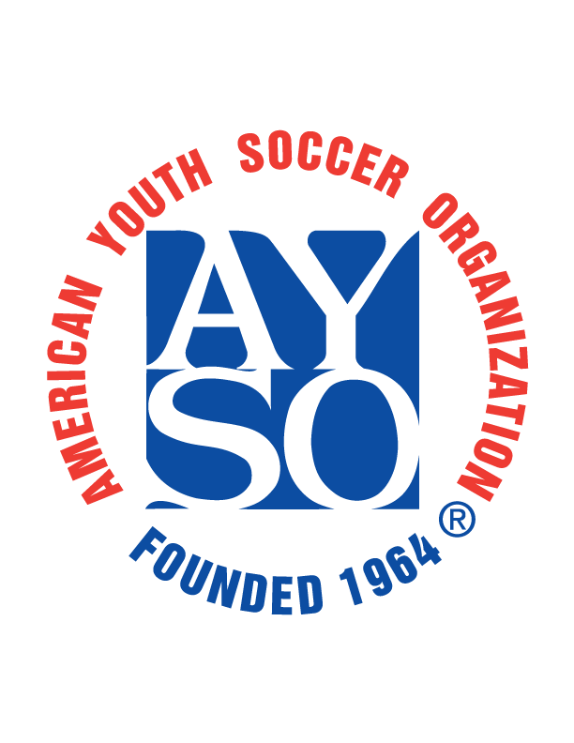

- Y. S. O. Region 294
Our AYSO Region NEEDS YOUR SUPPORT!

Dear AYSO Sponsor:
AYSO 294 had > 240 kids registered last year. We could not have had this program without your support! The registration fee paid by each player covers only a portion of the total expense.
Your gift directly supports this quality, extra-curricular program for our youth.
You will receive the gratitude and recognition from local families who are doing what we can to make sure EVERYONE PLAYS and has an enjoyable soccer experience.
All contributions are tax deductible¹ and the full amount of your sponsorship directly supports our AYSO Region, an all-volunteer organization. If you require more information, please contact the Regional Commissioner region294rc@gmail.com.
Thank You

1. AYSO is a non-profit corporation (tax ID #95-6205398; Section 501 (c) (3) of the Internal Revenue Code)

Sponsorship Level: Platinum ($800) Gold ($600) Silver ($400) Bronze ($200)
Other donation amount: ($ )
Please email your logo to region294rc@gmail.com for publishing on our website ayso294.org

Sponsor Name:
Website:
Mailing Address:
City, State, Zip:
Contact Name: Telephone:
Email:

Please make your check payable to American Youth Soccer Organization. Mail this voucher with your check to:
AYSO Region 294
P. O. Box 2121
Lake Isabella, CA 93240

